“MEETING SUMMARIZER”
A
Project Synopsis Report
submitted in partial fulfillment of the
requirements for the award of the degree of

BACHELOR OF TECHNOLOGY
in
COMPUTER SCIENCE & ENGINEERING

Prepared by

Specialization | SAP ID | Name
BTech CSE (CCVT)B5 | 500101763 | Rishika Raj
BTech CSE (CCVT)B4 | 500101953 | Anshi Mehta
BTech CSE (CCVT)B4 | 500106345 | Dhananjay Baliyan

under the guidance of
Pavinder

School of Computer Science
UPES, Dehradun, Uttarakhand - 248007
Table of Contents
S.no. | Title | Page no.
 | Abstract | 3
1 | Introduction | 3
 | 1.1 Technical concepts used | 3
 | 1.2 Motivation | 5
 | 1.3 Problem Statement | 5
 | 1.4 Area of application | 5
 | 1.5 Dataset and Input Format | 6
2 | Literature Review | 6
 | 2.1 Related work | 6
 | 2.2 SWOT Analysis | 6
3 | Objectives | 8
 | 3.1 Project Objectives | 8
4 | Methodology | 9
 | 4.1 Reference Software Model | 9
 | 4.2 Implementation Steps/Phases | 9
 | 4.3 Timeline and PERT Chart | 11
5 | Conclusion | 12
 | 5.1 Scope of Project | 12
 | 5.2 Conclusion | 12
6 | Reference | 13
 | 6.1 List of cited papers | 13

ABSTRACT
Cloud computing and artificial intelligence's quick development has created new opportunities to boost teamwork and productivity in work settings. Effectively recording and summarizing meetings, which frequently include important information and action items, is a major difficulty for organizations. In order to provide precise and effective summaries of meeting content, this project presents a web-based meeting summarizing system that makes use of AI-powered natural language processing techniques. The system processes recorded or live meeting audio by combining deep learning-based text summarization models with speech-to-text conversion. The system's user-friendly interface allows users to attend live meetings or upload audio files, and it provides structured summaries that include important choices and debate topics. This technology facilitates more effective communication and faster workflows by saving time, reducing manual labor, and improving knowledge retention for professionals and teams.

1. INTRODUCTION
1.1 Technical Concepts Used
In order to provide precise meeting transcription and summary, the system combines deep learning and speech recognition algorithms with sophisticated artificial intelligence and natural language processing (NLP) methodologies. To accurately convert audio input into text, a cutting-edge speech-to-text model—like Google Speech API or OpenAI's Whisper—is used. After transcription, important points, action items, and general meeting insights are extracted using a transformer-based summarization model (such as BERT, T5, or GPT).
The application's backend is created with a contemporary web framework, like Flask or Django, which allows for smooth communication between the cloud-based storage and services and the transcription/summarization engine. With the use of technologies like HTML, CSS, and JavaScript, the frontend is created with a responsive and user-friend interface to guarantee seamless user interaction and simple accessibility.
Scalability, safe data storage, and on-demand resource provisioning are ensured by cloud services like AWS, Google Cloud, or Azure. The platform also includes a session management and user authentication system, which enables users to obtain transcripts and summaries and view their own meeting histories. Versatility and a simplified user experience are guaranteed by real-time processing capabilities and support for numerous file formats.

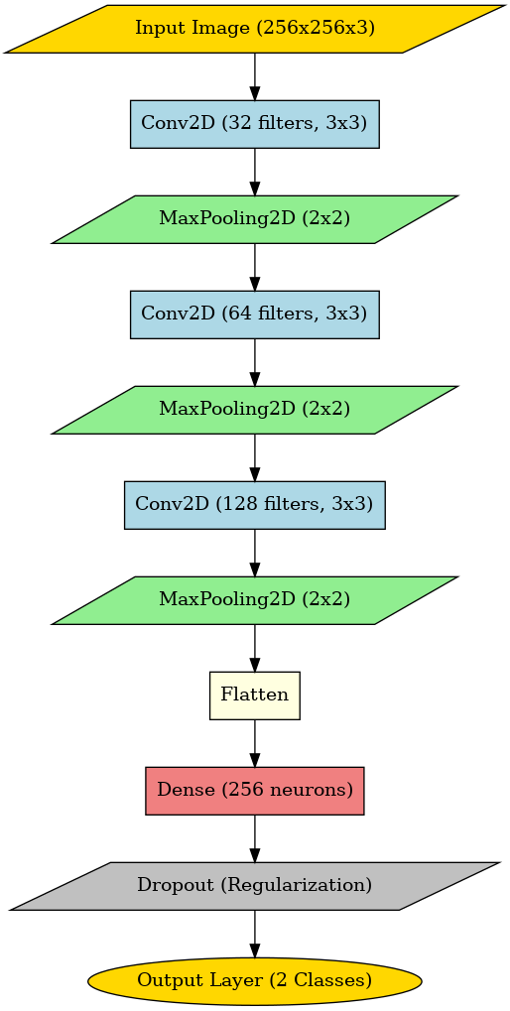
Figure: CNN Flowchart

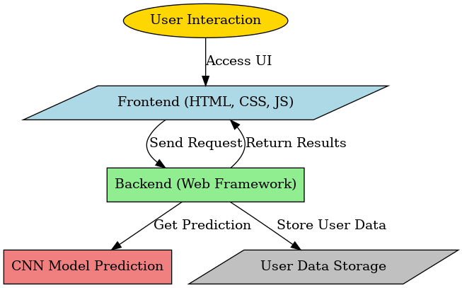
Figure: Integrated Flowchart
1.2 Motivation
Agriculture remains one of the most crucial sectors of the global economy, and any challenges that affect crop yield and quality have far-reaching consequences. Among these challenges, plant diseases are one of the leading causes of crop failure. Traditional methods of disease detection rely heavily on manual inspection, which is not only time-consuming but also prone to errors. Given the increasing demand for food security and sustainable farming, an automated and reliable disease detection system is the need of the hour.
The motivation behind this project stems from the necessity to provide an accessible and efficient tool for farmers to detect diseases at an early stage, thereby reducing potential losses. With the integration of deep learning, this system offers an accurate and scalable solution that can benefit the agricultural community, researchers, and agricultural extension services.
1.3 Problem Statement
Tomato cultivation is highly susceptible to various diseases, many of which are difficult to detect in their early stages. If left untreated, these diseases can cause significant economic losses to farmers. The current disease detection methods, which rely on manual inspection, are neither scalable nor efficient. Given the vast scale of tomato cultivation, there is a need for an automated system that can quickly and accurately identify common tomato leaf diseases.
The primary goal of this project is to address this issue by developing a deep learning-based system capable of detecting tomato leaf diseases with high precision. The system should be easy to use, accessible to farmers, and capable of providing real-time disease detection results with confidence scores.
1.4 Area of Application
This project finds various areas of application such as:
- Agriculture & Farming – Helps farmers detect plant diseases early, preventing crop loss and improving yield quality.
- Precision Agriculture – Can be integrated into smart farming techniques using AI for real-time disease monitoring.
- Food Security – Reduces crop loss, ensuring a stable food supply and better productivity.
- Agri-Tech Industry – Can be used by Agri-Tech companies to develop AI-based disease detection tools for commercial use.
- Supply Chain & Export Quality Control – Ensures that tomatoes with diseases don’t reach markets and exports, maintaining quality standards.
- Agricultural Research – Supports scientists in studying plant diseases, resistance, and climate effects on crops.
- Government & Agricultural Policies – Can be used to develop better disease prevention strategies and policies for sustainable farming.
- Mobile & Web-Based Applications – Can be turned into an app where farmers upload leaf images to get instant disease diagnosis and treatment recommendations.
1.5 Dataset and Input Format
The system requires high-quality images of tomato leaves as input for disease classification. The dataset comprises various images of tomato leaves affected by Septoria leaf spot as well as those affected by Two-spotted spider mite infestation. These images are preprocessed and resized to a standardized dimension to ensure uniformity in model predictions. The input formats supported include commonly used image formats such as JPEG and PNG.
Dataset Link: https://www.kaggle.com/datasets/ashishmotwani/tomato
2. LITERATURE REVIEW
2.1 Related Work
- Durmuş, H., Güneş, E. O., & Kırcı, M. (2017, August). Disease detection on the leaves of the tomato plants by using deep learning. In 2017 6th International conference on agro-geoinformatics (pp. 1-5). IEEE.
- Agarwal, M., Singh, A., Arjaria, S., Sinha, A., & Gupta, S. (2020). ToLeD: Tomato leaf disease detection using convolution neural network. Procedia +Computer Science, 167, 293-301.
- Hossain, M. I., Jahan, S., Al Asif, M. R., Samsuddoha, M., & Ahmed, K. (2023). Detecting tomato leaf diseases by image processing through deep convolutional neural networks. Smart Agricultural Technology, 5, 100301.
2.2 SWOT Analysis
Strengths
- High Accuracy: Uses CNN-based architectures (e.g., MobileNet, ResNet, EfficientNet) for superior disease classification.
- Automated Feature Extraction: Deep learning eliminates the need for manual feature selection.
- Scalability: Can be deployed on cloud or edge devices for real-time disease detection.
- Generalization Ability: Can be trained on diverse datasets to improve model robustness.
Weaknesses
- High Computational Cost: Training deep models requires GPUs/TPUs, making deployment expensive.
- Data Dependency: Performance is highly dependent on high-quality labeled datasets.
- Overfitting Risks: Models might overfit if not properly regularized (e.g., dropout, data augmentation).
- Hardware Constraints: Edge deployment is challenging due to large model sizes and processing power needs.
Opportunities
- Edge AI & IoT Integration: Can be embedded into low-power devices for real-time field analysis.
- Transfer Learning: Using pre-trained models reduces training time and boosts accuracy.
- Cloud-Based Deployment: Model inference can be run on cloud servers to overcome hardware limitations.
- Precision Agriculture Applications: Can integrate with drone-based or robotic systems for automated monitoring.
Threats
- Adversarial Attacks: Susceptible to perturbations in images that can mislead predictions.
- Data Variability: Variations in lighting, camera quality, and leaf orientation can reduce model effectiveness.
- Limited Benchmark Datasets: Few standardized datasets for tomato disease classification.
- Energy Consumption: Running deep models on GPUs continuously is resource-intensive.
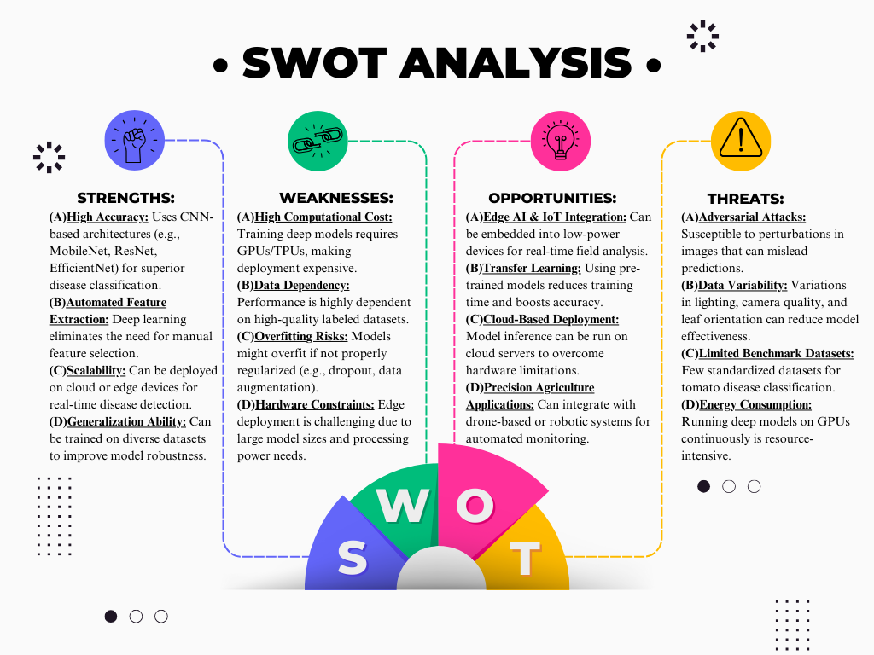
Figure: SWOT Analysis Diagram
3. OBJECTIVES
3.1 Project Objectives
The primary objectives of this project include:
1. To design and develop automated web-based system using deep learning for detection and classification of tomato leaf diseases. The sub objectives include:
  - Implement a deep learning model capable of identifying and classifying various tomato leaf diseases with high accuracy.
  - Integrate the model into a web-based platform, ensuring seamless accessibility for farmers, researchers, and agricultural experts.
  - Optimize the system for efficiency, allowing for real-time or near-real-time processing of uploaded images.

2. To create a user-friendly interface that allows users to upload images and access real-time disease detection results. The sub objectives include:
  - Develop an intuitive and responsive web interface that simplifies image uploading for users with varying levels of technical expertise.
  - Display clear and concise disease detection results, including disease type and confidence score.
  - Ensure cross-device compatibility, allowing users to access the system from desktops, tablets, and mobile devices.

4. METHODOLOGY
4.1 Reference Software Model
The project follows an iterative development model, ensuring continuous improvement and enhancement of system functionality. The Django MVT (Model-View-Template) architecture is employed to build the web application, providing a structured and scalable approach to integrating the deep learning model with the user interface.
4.2 Implementation Steps/Phases
1. Literature Review
- Review existing research on tomato plant diseases and their visual symptoms.
- Analyze previous deep learning approaches used for plant disease detection.
- Identify datasets used in prior studies and their effectiveness in model training.
2. Requirement Identification
- Define project objectives and scope.
- Determine hardware and software requirements, including computing resources and necessary libraries.
- Identify dataset sources, ensuring high-quality labeled images of tomato leaves.
- Specify performance evaluation metrics for model assessment.
3. Comparative Study
- Compare various deep learning architectures (e.g., CNN, ResNet, EfficientNet) for plant disease detection.
- Evaluate different preprocessing techniques for enhancing image quality.
- Assess existing plant disease detection systems to identify gaps and potential improvements.
4. Design and Development
- Develop a data preprocessing pipeline and select an appropriate CNN architecture.
- Implement a training pipeline using TensorFlow/Keras or PyTorch.
- Model optimization
5. Implementation
- System Design and Setup: This phase involves designing the overall system architecture, setting up the database schema, and implementing the user authentication module to ensure user access.
- Model Integration: The CNN model is trained using labeled images of tomato leaves. The trained model is then integrated with the backend system to facilitate real-time predictions upon image uploads.
- Frontend Development: A responsive and interactive web interface is developed using Bootstrap and Django templates. The interface allows users to upload images and view detection results.
6. Results and Analysis
- Evaluate model performance using pre-defined performance metrics.
- Compare model performance with existing systems.
- Conduct user testing and collect feedback for system improvements.

4.3 Timeline and PERT Chart
S.no. | Task | Duration
1 | Problem Statement Definition | 3 days
2 | Literature Review | 5 days
3 | Requirement Analysis | 4 days
4 | Synopsis Documentation | 2 weeks
5 | Dataset Collection | 2 weeks
6 | Data Preprocessing | 1 week
7 | SRS Documentation | 1 week
8 | Model Selection | 1 week
9 | Design and Development | 2 weeks
10 | Validation and Testing | 2 weeks
11 | Result Analysis | 1 week
12 | Model Evaluation | 1 week
13 | Final Report Documentation | 2 weeks

Figure: Project Timeline

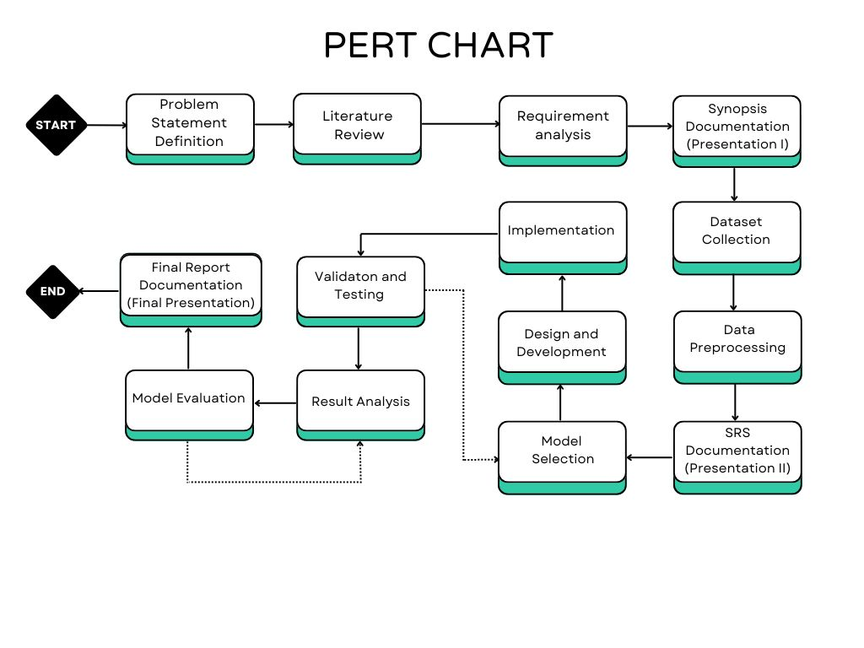
Figure: PERT Chart

5. CONCLUSION
5.1 Scope of project
The current scope of this project includes:
- Detection and classification of two specific tomato leaf diseases: Septoria leaf spot and Two-spotted spider mite infestation.
- A web-based platform with user authentication and intuitive user experience.
- Real-time image processing and disease detection with confidence scores.
- Standardized image preprocessing to ensure consistency in predictions.
The future scope of this project aims to expand the system’s capabilities by:
- Increasing the number of detectable tomato leaf diseases.
- Extending support for mobile applications for greater accessibility.
- Developing an offline detection module for areas with limited internet connectivity.
- Integrating the system with crop management solutions to provide actionable insights.
5.2 Conclusion
The Deep Learning-based Tomato Leaf Disease Detection System presents an effective solution for early disease detection, leveraging modern AI techniques to assist farmers and agricultural experts. By automating the disease detection process, this system minimizes human errors and enhances agricultural productivity. Future enhancements will make the system more comprehensive, supporting a broader range of plant diseases and offering advanced analytical features.

6. REFERENCE
6.1 List of cited papers
- Durmuş, H., Güneş, E. O., & Kırcı, M. (2017, August). Disease detection on the leaves of the tomato plants by using deep learning. In 2017 6th International conference on agro-geoinformatics (pp. 1-5). IEEE.
- Agarwal, M., Singh, A., Arjaria, S., Sinha, A., & Gupta, S. (2020). ToLeD: Tomato leaf disease detection using convolution neural network. Procedia Computer Science, 167, 293-301.
- Hossain, M. I., Jahan, S., Al Asif, M. R., Samsuddoha, M., & Ahmed, K. (2023). Detecting tomato leaf diseases by image processing through deep convolutional neural networks. Smart Agricultural Technology, 5, 100301.

